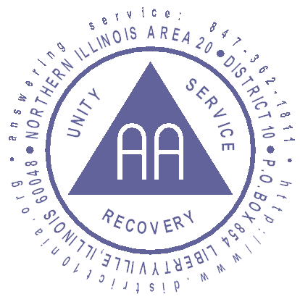

AREA 20

DISTRICT 10 MONTHLY MEETING

August 24, 2008

6:00 pm Cheryl V. opened the meeting with a quiet time and Concept #8.

Attendance: 43

Introduction for first time attendees:
Bill - visitor
Janet – visitor
Chuck – GSR, Washburn Church
Norris – visitor
Steve – GSR, Thursday 7a.m.
Brittney – visitor
Stacy – visitor

Anniversaries:
Greta – 9 years
Jill – 8 years
Kevin – 4 years

Secretary’s Report:
Thank you Genevieve for collecting and writing the meeting minutes from July. July Minutes were post on the web page August 23rd and have not been review, so a motion to accept them will be held in September.

Treasurer’s Report:
Carmela R – Reviewed August spending and income, then read “Where money and personalities mix”. Brian motioned to accept; Selby seconds the motion. All were in favor. Full financial summary can be found at the end of these minutes in Attachment A.

GSR Reports:
Greta – GSR Sat “A Way Out” – Saturday October, 18th at 6pm we are having an anniversary party.
Alan – GSR, Vernon Hills Open Sat P.M. – Our meeting needs support!

Old Business:
- Sober Fest - Jay announced the Fest is 3 months away and if your group is interested in sponsoring a two hour slot in the hospitality room please call Rich B @ 815-579-3508. If you would like details please visit www.soberfest.org

- September Elections – Cheryl reviewed the different positions available and provided a hand out with descriptions. The hand out can be found at the end of these minutes in Attachment B.

New Business:
- NIA 20 Fall Assembly is coming up on September 13th at the Bethel Baptist Church in Galesburg, IL.

- Primary Purpose Finance 2009 Basic Register – Cheryl V presented the proposed upcoming motion. The motion is designed to review in more detail the expenses of the Area delegates and determine if there are things that should be included in the budget for the future. (i.e. travel expenses).

Committee Reports
Directory:
John – We have approximately 350 directories left. September 30th is the deadline for change submissions. Please e-mail changes to directory@dist10nia.org.

Answering Service:
Greg reported numbers for 5/26/08-6/19/08:
Total 150
Meeting Information 50
12 Step 14
Spanish Meetings 1
Other Districts 20
Hang Up/ call back 26
Alanon/ NA. 15
Wrong number 7
Miscellaneous 0
Website info 5
Solicitors 12

Treatment:
Jay – with the help of Mark H. we made a contact at the Lake County Health Department in Lake Villa. They have a Tuesday night meeting there which is not listed in the directory. Also, I cleaned up the inventory of literature.

Public Information:
Rick – We had seven groups sign up this month for the business card program. The program is design so a group can adopt a public facility (library, police station, etc.) and post A.A. business cards on site. The cards will list a phone number where someone can all for help. The group is responsible to follow up with the public facility to keep business card inventory replenished and see if the facility has questions.

CPC:
No report

Grapevine:
Matt – Noted the old Alt Chair phone number for GV is still listed in the Conscious Contact. This needs correction!

Literature:
No report

Corrections:
Inventory on hand:
One case of BB, English
One case of BB, Spanish
Half Dozen 12 X 12, English and Spanish
Grapevines and miscellaneous pamphlets.
Thanks to District 28 for their contribution of one case of BB.
The Area Correction Chair, Rich H., will be supplying the District with three cases of Big Books in the next few weeks. There were two applications that did not receive approval.
Thanks to the Wednesday 8 PM Round Lake Community Church for their Pink Can donation as well as those groups we are not aware of for their continued support.

Newsletter:
Lisa – September 24th deadline for the October edition; September edition is on the table.

Archives:
No report

Special Needs:
No report

Events:
Felicia – District 10 Fall Breakfast tickets and fliers are available. The breakfast is on Sunday October 26th at the Waukegan Ramada Inn. Coffee at 8, breakfast at 9 and tickets cost $15.

Website:
Gail reviewed the number of hits.

GSR Contact Committee:
No report

Officers Reports DCM, Alt DCM:
Alternate DCM :
Scott – No report

DCM Report
Cheryl – No report

ATTACHMENT A – Secretary Detail
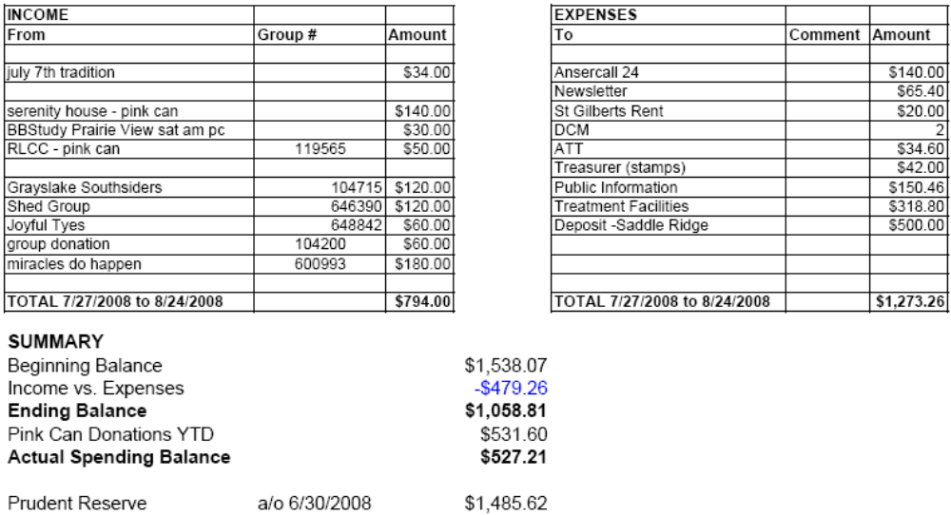

CONTINUED
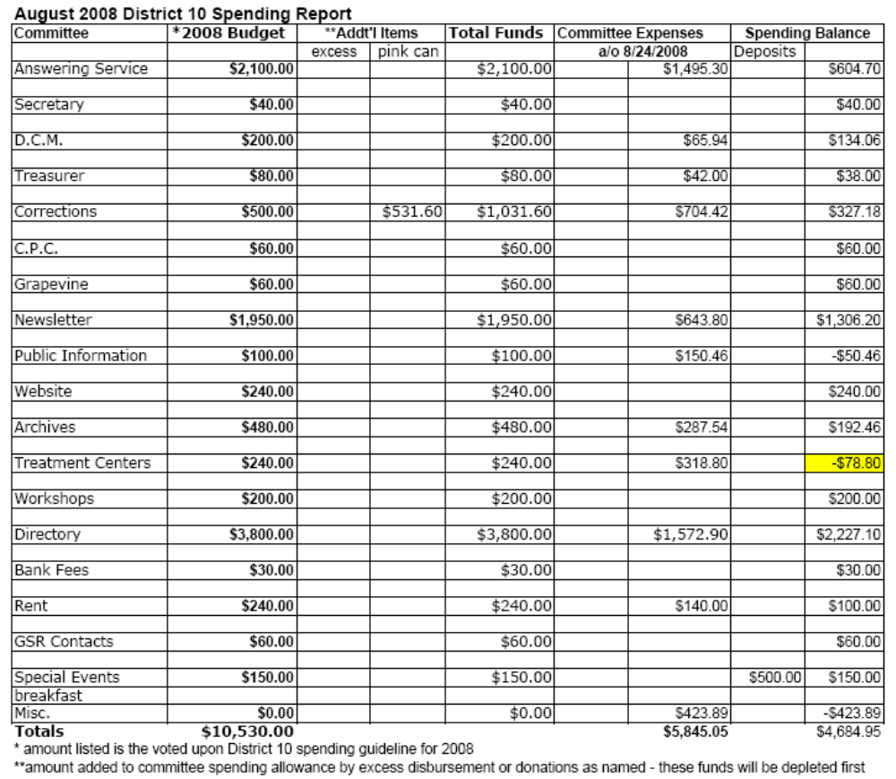

Attachment B
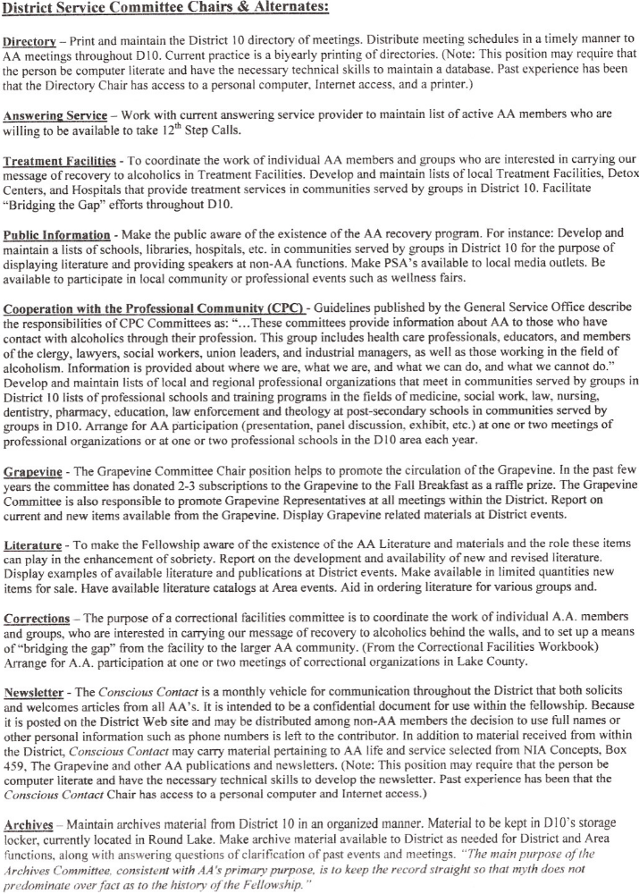
CONTINUED



